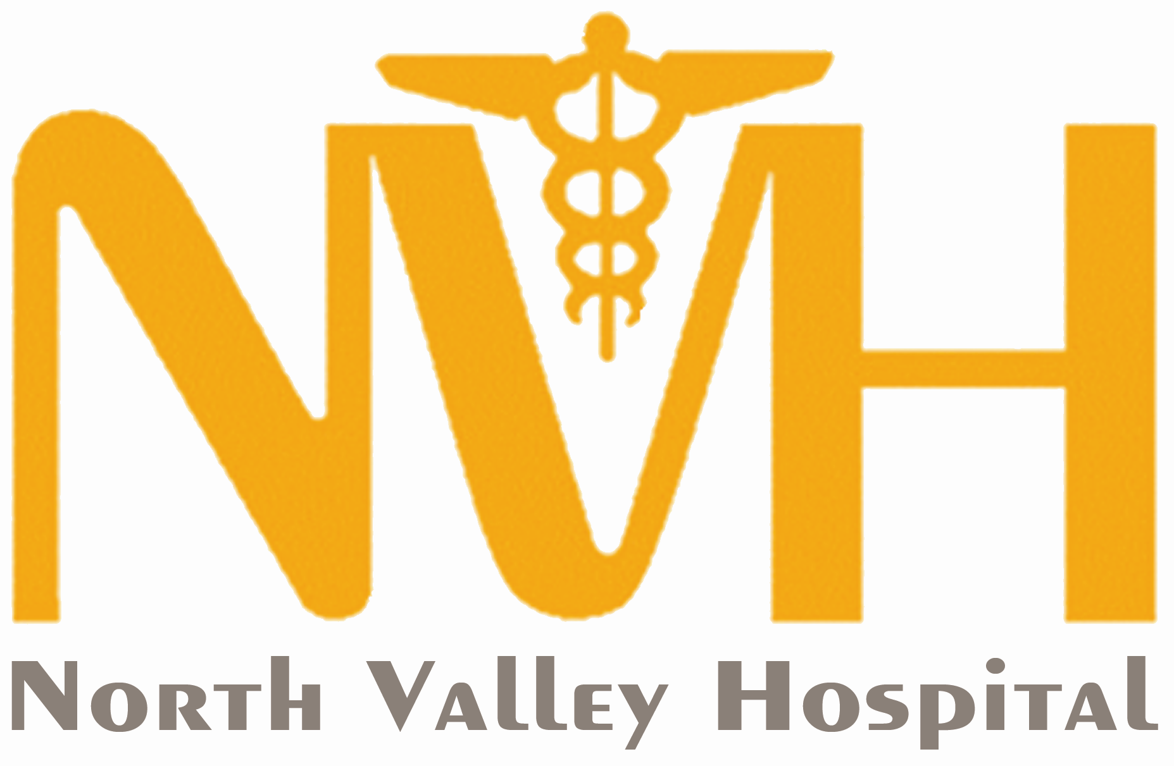
TAX DISCOUNT PROGRAM

Eligibility
Own a parcel located within the boundaries of North Valley Hospital District No. 4 on which part of your taxes are paid to the hospital.

Amount Allowed
Maximum tax discount of $500 will be allowed per calendar year for the actual amount paid each year in taxes on the parcel located within the boundaries of Okanogan County Public Hospital District No. 4. The annual amount will never exceed the amount under the general distribution section of your property tax statement for Okanogan County Public Hospital District No. 4.

Inclusions
Taxpayer and legal dependents.

Coverage
Within 120 days from the date that services were billed, or 120 days from the date other insurance paid all they will pay on your hospital bill.

Exclusion
Past due accounts and/or accounts turned over to collections will not be considered for the tax discount program.

How to apply for Tax Discount
- Complete “Application for Tax Discount” provided, attaching necessary documentation as required.
- Mail or bring in the completed application to the front desk of North Valley Hospital. You may also call to apply for the discount over the phone.
- After application has been approved, your account will be credited for the approved amount.

For More Information
For help filling out the application or for more information, contact our Financial Services Department at North Valley Hospital by calling 509-486-2151.

GROWING HEALTHCARE CLOSE TO HOME
www.nvhospital.org



Application for Tax Discount

Taxpayer Name:_______________________________________________________________

Taxpayer Address:_____________________________________________________________

Taxpayer Phone or Contact Info: Home (___)___-____ Cell (___)___-____

If any dependents will be included in your tax discount, you must attach a copy of your income tax return to establish dependent eligibility. If you choose not to include a copy of your income tax, dependents will not be considered in this discount.

Dependents Name | Address (if different than taxpayers) | Relationship to Taxpayer

I own a parcel located within the boundaries of North Valley Hospital District. Attached is my tax statement as proof of assessed hospital district taxes for the current year._________
Initial

I understand that any and all insurance benefits due for the services rendered, whether billed by me or the Hospital, must be applied before I may take advantage of the tax discount program.

Signature of Taxpayer____________________________________ Date:_______________________

